Francesco SANTAGIUSTINA Quantum Information and computing

Lab. report 1 : Bell’s inequality test

**Experimental setup:**

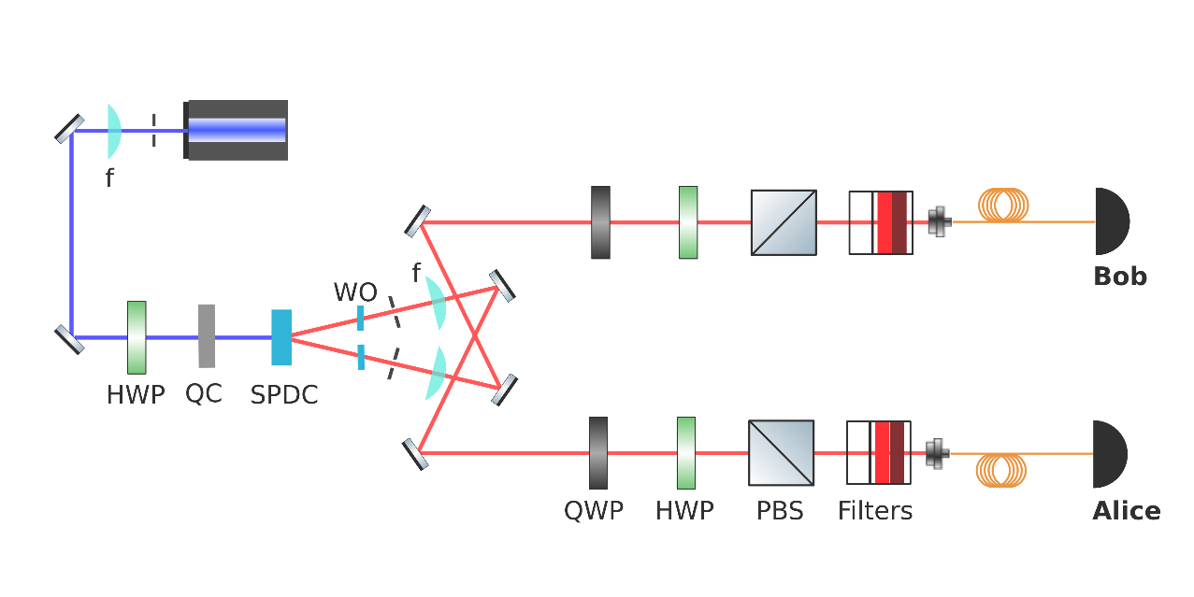

Figure 1: Scheme of our apparatus, please note the following elements: half-wave plates (HWP), polarizing beam splitters (PBS), quartz crystal (QC) and the spontaneous parametric down-conversion crystal (SPDC), the quarter-wave plate (QWP) is not used in this experiment. Alice and Bob represent the two detectors: single-photon avalanche diodes (SPAD).

**Experiment theoretical description:**

In this laboratory experience we aim to show how a falsification of the local realism hypothesis is achievable. Instead of the original inequality due to Bell [[1]], we will try to violate a different formulation also derived from the local hidden variables theory: the CHSH inequality [[2]]. This inequality also expresses a bound on correlations of measurements performed on two separate systems. More precisely if we consider the polarization of two photons A and B, measured using two polariser rotated of angles α and β (i.e. we consider four possible outcomes: VαVβ , HαVβ , VαHβ , HαHβ ), and define the correlation of the two measurements outcomes as :

$$E\left(α, β\right)≡P_{VV}\left(α, β\right)+P_{HH}\left(α, β\right)-P_{VH}\left(α, β\right)-P_{HV}\left(α, β\right)$$

it can be shown that for any set of polariser angles $\left\{a,a^{'},b,b'\right\}$ the following relation must hold in any physical world where locality and realism principles both hold (assuming no superdeterminism) $-2≤S≤2 where S≡E\left(a,b\right)-E\left(a,b^{'}\right)+E\left(a^{'},b\right)+E\left(a^{'},b^{'}\right).$

In order to test this hypothesis we prepare by parametric down conversion EPR pairs of photons (whose polarizations are entangled) and let them propagate through the two branches of our measurement apparatus and infer an estimation of the probabilities of the measurement outcomes from the count of time-coincident detections obtained at detectors Alice and Bob, specifically if we suppose that we count the photons coming out of the $|H>$ side of the PBS we have that: $P_{HH}\left(α, β\right) = N\left(α, β\right)/N_{tot} ; P_{HV}\left(α, β\right) = N\left(α, β_{⊥}\right)/N_{tot}$

$${ P}_{VH}\left(α, β\right) = N\left(α_{⊥}, β\right)/N_{tot} ; P_{VH}\left(α, β\right) = N\left(α_{⊥}, β_{⊥}\right)/N_{tot}$$

with $N_{tot}= N\left(α, β\right)+ N\left(α_{⊥}, β_{⊥}\right) +N\left(α_{⊥}, β\right) +N\left(α, β_{⊥}\right)$ and $α_{⊥}= α + 90°$, $β_{⊥}= β + 90°$

being the orthogonal polariser angles.

We thus needed 16 measurements in total (4 correlations times 4 measurements per correlation).

**Practical implementation of the measurements and pre-processing:**

Now going into practical implementation, we chose as set of polarisation angles $\left\{a = 0°,a^{'}= 45°,b =-22.5° ,b' = 22.5°\right\}$ (these are actually only offsets applied ideally to the polariser, in practice we will turn the half-wave plates of one half the indicated angle after having calibrated them in order to project onto $|H>$) and performed counts measurement each time for over 5 seconds. We used a laser of 405 nm wavelength (doubled by the SPDC), calibrated the half-waves plates by producing $|HH>$ photons pairs and let the coincidence counts match the Malus law (especially on max and min points), obtaining : $\left\{ 13° → |H>, 58° → |V> , 35.5°→ |D>, 80.5° →|A>\right\}$ for the first wave plate and $\left\{ 64° → |H>, 109° → |V> , 86.5°→ |D>, 131.5° →|A>\right\}$ for the second one. To produce the Bell state one has first to balance $|HH>$ and $|VV>$ production by turning the HWP placed after the laser and then by rotating the birefringent quartz plate we can set the phase difference between the two components : to set it zero and produce ${|Φ}^{+}>$ we try to minimize ${<DA|Φ}^{+}>={<AD|Φ}^{+}>≈0$ whereas to set the phase to π and produce ${|Φ}^{-}>$ we try to minimize ${<DD|Φ}^{-}>={<AA|Φ}^{-}> ≈0$. The detector acquisition software output is a text file containing the arrival time (expressed in time units of 80.955 * 10^(-12) s) of each detected photon for both channels. The pre-processing thus consisted of set the reference initial time at 0, converting the unit of time to 1 s and keeping only data of the first five seconds in order to get comparable count rates for each measurement. Then it was necessary to keep only coincident photons counts, in order to do this I matched each photon arrival time-tag from one channel to the closest in the other channel and computed their time differences (this approach isn’t perfect because a photon of the second channel could be matched many times to one of the first channel, even if it is improbable). Then I plotted an histogram of the time differences, and noticed that there was a little gaussian cantered nearly around zero so I discarded all time differences greater than 2*10.*(-9) s in absolute value and plotted the histogram again because values above this threshold were obviously coming from noise (or not corresponding to true pairs) with very high probability. In this way I have been able to compute the variance of this gaussian and to use its double as coincidence time window : all time differences falling inside it after removing from their value the mean of the gaussian (which could be related to a slight difference in the optical path of the two branches) have been considered as corresponding to true coincident pairs of photons.

**Results and error estimation:**

By repeating this procedure for each file x*a*y*b*.txt corresponding to a different measurement setup *Table 1* has been obtained. Columns tell what polariser angle has been used in channel 1 and rows in channel 2. For instance, x0 or x1 represent the choices of $α = a = 0°$ or $α = a'= 45°$ while a0 or a1 say if we performed the measurement with the original angle or the orthogonal one ; the same goes respectively for y and b in channel 2.

***Table 1: Table of coincidence counts in a 5s test.*** ***Table 2: Correlations obtained from Table 1 counts.***

We can notice that *Table 1* data is divided into four 2x2 matrices, where each matrix contains the counts necessary to compute one correlation estimate, which is simply given by the sum of the diagonal terms minus the sum of the antidiagonal terms, all divided by the sum of all terms :

$$E\left(α, β\right)≈ \frac{N\left(α, β\right)+ N\left(α_{⊥}, β_{⊥}\right) - N\left(α_{⊥}, β\right) -N\left(α, β_{⊥}\right)}{N\left(α, β\right)+ N\left(α_{⊥}, β_{⊥}\right) +N\left(α_{⊥}, β\right) +N\left(α, β_{⊥}\right)} .$$

It is now immediate to compute the desired quantity and see that it violates the CHSH inequality:

$S≈0.6600-(-0.5821)+0.6362+0.6125 ≈ 2.4907 > 2$.

However we need to characterize the estimation error in order to know how reliable is our result. First let’s note that accidental coincidences, that is coincidences due to random arrivals in the same coincidence window, acts to decrease $|S|$ as stated in [[3]] so they cannot be held responsible for the violation of Bell inequalities. Now, we can model each of our coincidences count as a Poisson process and thus consider its variance equal to its average (obviously estimated by the actual value), so for each count $N_{i}$ we can compute its standard deviation as $σ_{N_{i}=}\sqrt{N_{i}}$. Then we find the standard deviation of the final result by applying the formula:

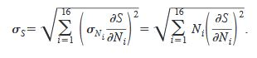

The computation is not so difficult if we consider that $N_{i}$ only appears in one correlation $E\left(α_{i},{ β}_{i}\right)$:

$$\left|\frac{∂S}{∂N_{i}}\right| = \left|\frac{∂E\left(α_{i},{ β}_{i}\right)}{∂N_{i}}\right|=\left|\frac{∂\left(\frac{c_{i}{±N}_{i}}{N_{i} +d_{i}}\right)}{∂N_{i}}\right|=\left|\frac{d_{i}∓c_{i}}{{\left(N_{i}+d_{i}\right)}^{2}}\right|= \left|\frac{(1∓E\left(α_{i},{ β}_{i}\right))}{N_{i, tot}}-\frac{N_{i}∓ N_{i}}{{\left(N_{i, tot}\right)}^{2}}\right|$$

where $c_{i}=$ $E\left(α_{i},{ β}_{i}\right)∓N_{i}$ and $d_{i}= N_{i, tot}- N_{i}$ are not varying with $N_{i}$ and the top sign must be chosen for $N_{i}$ corresponding to direct correlations (diagonal elements of 2x2 matrices) while the bottom sign must be chosen for those corresponding to anticorrelations (antidiagonal elements of 2x2 matrices). By computing all of this in MATLAB we get $σ_{S}≈0.0162$ so we are breaking the CHSH inequality with very high confidence.

It is interesting to note that also in quantum mechanics, $|S|$ cannot be arbitrarily high, the Tsirelson bound [[4]] on CHSH inequality prove that $|S|<2\sqrt{2}≈2.8284$ and it would have been reached for a perfectly prepared EPR pair.

**Additional notes:**

The MATLAB algorithm used to obtain all the previous results can be found in the folder “Lab1 MATLAB code”, the main file that need to be run is “LAB1.m”, it is essential that the main file is kept together with all its subroutines contained in the other “*.m” files and the experimental data in “x*a*y*b*.txt” files. The algorithm execution may take a few minutes, I made it show the time-differences histograms for each file in order to follow the progression of pre-processing.

1. [1] J.S. Bell (1964), "On the Einstein Podolsky Rosen Paradox", Physics, **1**: 195–200, reproduced as Ch. 2 of J. S. Bell (1987), Speakable and Unspeakable in Quantum Mechanics, Cambridge University Press.
2. [2] J.F. Clauser; M.A. Horne; A. Shimony; R.A. Holt (1969), "Proposed experiment to test local hidden-variable theories", Phys. Rev. Lett., **23** (15): 880–4.
3. [] Dehlinger, Dietrich, and M. W. Mitchell. “Entangled Photons, Nonlocality, and Bell Inequalities in the Undergraduate Laboratory.” *American Journal of Physics* 70, no. 9 (August 13, 2002): 903–10. https://doi.org/10.1119/1.1498860.
4. [] Cirel’son, B. S. “Quantum Generalizations of Bell’s Inequality.” *Letters in Mathematical Physics* 4, no. 2 (March 1, 1980): 93–100. https://doi.org/10.1007/BF00417500.